**LeetCode problem : Buy and sell O(n)**

**Problem Statement**

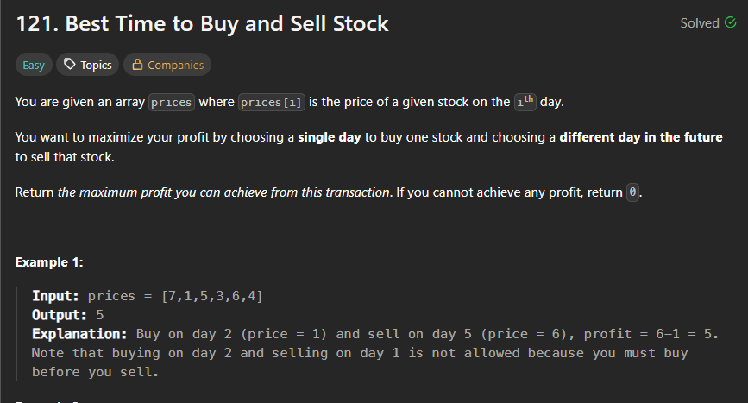

**Code Snippet**

class Solution {

public:

    int maxProfit(vector<int>& prices) {

        int bestBuy = prices[0]; // Assume best buying price on day 1

        int maxProfit = 0;

        for (int i = 1; i < prices.size(); i++) {

            // Update maxProfit if selling today gives better profit

            maxProfit = max(maxProfit, prices[i] - bestBuy);

            // Update bestBuy if today's price is lower

            bestBuy = min(bestBuy, prices[i]);

        }

        return maxProfit;

    }

};

**Output** 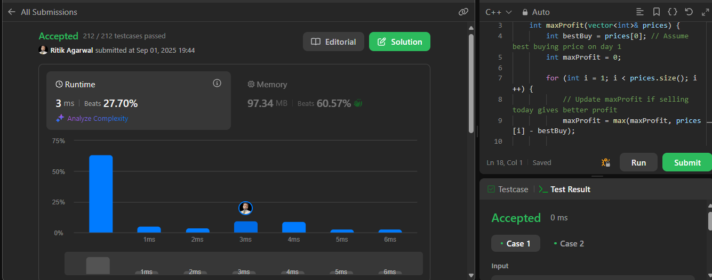

My learnings

1. I learnt visualisation of the problem and solution statement